

FACULTY OF ELECTRICAL ENGINEERING

UNIVERSITI TEKNOLOGI MARA (UiTM)

MICROPROCESSOR SYSTEMS

(ECE521)

HAND CONTROLLED ROBOTIC ARM

|  |  |
| --- | --- |
| NAME | UiTM Student No. |
| Muhamamad Fitri b Mohd Hanafi | 2017943289 |
| Muhammad Azhad b Zuraimi | 2017195779 |
| Nur Fasehah bt Sulaiman | 2015282926 |

EE241 4C

DR SHAHRANI BINTI SHAHBUDIN

TABLE OF CONTENTS

|  |  |
| --- | --- |
| Topic | Page |
| Project Objectives | 1 |
| System Description and System Operation | 2-3 |
| Project Scope | 4 |
| Hardware Design | 5-9 |
| Software Design | 10-20 |
| Testing and Debugging | 21 |
| Results | 22-25 |
| Entrepreneurial Opportunity | 26 |
| Financial Management | 27 |
| Conclusion and Recommendation | 28 |
| Reference | 29 |

**1.0 PROJECT OBJECTIVES**

The main objective of this project is to make a robotic hand that can perform several action based on human hand motion. Other than that, the objectives are also to be: -

1. To make a wireless controlled robotic arm that can be control from certain distances.
2. To design a hand motion controlled robotic arm by using 8051 microcontrollers.
3. To use RF transmitter and receiver in order to send signal from accelerometer sensor to the 8051 microcontroller.
4. To display the movement of the robotic arm in the LCD.

**2.0 SYSTEM DESCRIPTION AND SYSTEM OPERATION**

The project is used to perform several action of human hand to lift object such as upward, downward, gripping and releasing an object. The applications of this project can be applied in a places that need to lift heavy and large object such as factories, shipyard cargo and airport. By this, the job will be easier as they didn’t have to use forklift. Other than that, the system also can be controlled by wireless system and it is not the basic wireless things such as Bluetooth and infrared. The goal of this system is to measure the acceleration movement of the hand motion and at the same time move the robotic arm based on the signal received.

The accelerometer sensor is used in this system to measure the acceleration experienced by the sensor [1]. For this project, the sensor detects the hand motion as it is attach to the glove wears by the human. A three dimensional acceleration axis of human hand motion is measure by the accelerometer sensor with adequate accuracy and precision. The physical presence of the sensor should not alter the hand motion. Because of that, a small and lightweight accelerometer sensor which is ADXL345 is used to measure something sensitive as human hand motion.

The microcontroller used to receive input from the accelerometer sensor and transfer output to the RF module is Arduino microcontroller ATmega328P chip. This ATmega328P chip is supported with a full suite of program and system development tools including C compiler, macro assemblers, program simulator and evaluation kits. Thus a C programming is use to read the input data from the accelerometer sensor by the hand motion and give the data output to the RF module. The RF module used in this project is RF 433 MHz transmitter-receiver module.

RF transmitter receives serial data from the acceleration sensor and transmit it to the receiver through its antenna. When a logic 0 is applied to the transmitter, then there is no power supply in the transmitter. However, when the logic 1 is applied to transmitter, a high power supply in the range of 4.5mA with 3V voltage supply is received by the transmitter and it will turn ON. The encoder of HT12D is used to encode the signal received from the accelerometer sensor. They are capable of encoding 12 bit of information which consists of N address bits. On the other hand, the RF receiver receive the signal from the RF transmitter through antenna and then transfer the information to the 8051 microcontroller. The signal received firstly been decode by the HT12E decoder. In other words, HT12E transforms the inputs into output that is serial. It frees the 12-bit parallel data into serial for transmission.

The input from RF module signal will be received by the 8051 microcontroller. This 8051 microcontroller is the main component that been used in this project. This 8051 microcontroller use assembly language in its software. Many applications can be done using this 8051 microcontroller such as LCD display, keypad display, switch, LED display, motor rotation and also buzzer. The output of this 8051 microcontroller project is the two DC motors that will rotate to move the robotic arm based on the hand motion signal. The L298N motor driver is use as a medium to allow the speed and direction of both DC motors at the same time [2]. By the time the robotic arm moving during the process, the LCD also will display the robotic arm movement.

**3.0 PROJECT SCOPE**

**3.1 Literature Review**

The scope of work for this project is divided into mechanical and electrical process. The mechanical parts include the hardware design of the robotic arm and the hand glove with accelerometer sensor on it. However, the electrical part is focused on the DC motor rotations, the LCD display and also the whole programming. The scope of work of this hand motion robotic arm robot can be classified as this:

* The accelerometer sensor on the hand glove will detect the hand motion and read each axis speed. The user will make several gestures that has been installed such as up, down, roll left and right. The signal then be send to the ATmega328P microcontroller.
* The RF module send the input data to the 8051 microcontroller. Then the data will be send to the motor driver that hold DC motor.
* One DC motor will be use to move the robotic arm upward and downward. The other one will grip and release an object.
* The LCD will display the work done of robotic arm either “move upward”, “move downward”, “grip object” or “release object”.

**4.0 HARDWARE DESIGN**

The Table 1 shows the component used in this project and its description.

Table 1

|  |  |
| --- | --- |
| **COMPONENTS** | **DESCRIPTION** |
| Accelerometer sensor (ADXL345) | To measure the acceleration experienced by the sensor and its axis position. The output data of the acceleration sensor will determine the type of movement of the robotic arm. |
| RF Module (434MHz) | RF signals travel through antenna in the transmitter and receiver even when there is an obstruction. It operates at a specific frequency of 434MHz RF transmitter send the signal of the accelerometer sensor to the RF receiver through the antenna. |
| ATmega328P Microcontroller | This microcontroller is used to receive input signal from the accelerometer sensor and transfer the output to the RF module. |
| 8051 Microcontroller (AT89S52) | Received input data from RF module and send the output to the two DC motors and rotate the motors based on the programming install in it. |
| LCD | Display the movement of the robotic arm. |
| Encoder (HT12D) | Encoded parallel data of RF transmitter for transmission feed. |
| Decoder (HT12E) | Decoded the reception of the RF receiver. |
| L298N motor driver | A medium to allow the speed and direction of two DC motors at the same time. |
| DC motor | An actuator that move the mechanical designs. One DC motor is used to move the robotic arm upward and downward while the other one is used to grip and release the object. |

**4.1 Hardware Schematics**

1. Liquid Crystal Display (LCD)

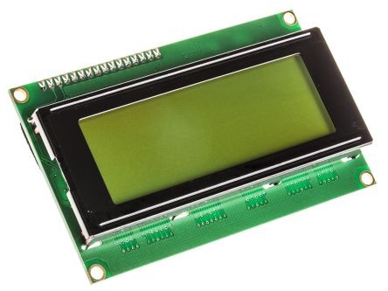

Figure 1: Liquid Crystal Display (LCD)

Liquid Crystal Display or LCD screen is one of the electronic display module. The one that been used is 16x2 LCD display is the very basic of the module and very commonly used in many devices and electronic circuits. The module is using the seven segments because it is cheap, easy to program and no limitation of displaying special characters, animation and others. The 16x2 LCD means it can display 16 characters per line and have 2 such lines. For this project, the LCD had been program to display “move upward”, “move downward”, “grip object” and “release object”.

1. AT89S52 Microcontroller Chip

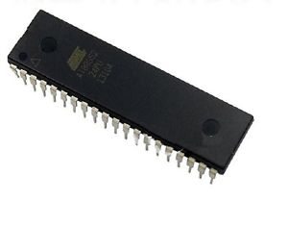

Figure 2: AT89S52 Microcontroller Chip

This chip is low-power but high-performance CMOS 8-bit microcontroller with 8KB of ISP flash memory. The device also uses Microchip high-density, non-volatile memory technology and is suitable with the industry standard 80C51 instruction set and pinout. The on-chip Flash allows the program memory to be reprogrammed in-system or by a conventional non-volatile memory programmer. By combining a versatile 8-bit CPU with in-system programmable Flash on a monolithic chip, the Atmel AT89S52 is a powerful microcontroller which provides a highly-flexible and cost-effective solution to many embedded control applications. The AT89S52 provides the following standard features: 8K bytes of Flash, 256 bytes of RAM, 32 I/O lines, Watchdog timer, two data pointers, three 16-bit timer/counters, a six-vector two-level interrupt architecture, a full duplex serial port, on-chip oscillator, and clock circuitry. In addition, the AT89S52 is designed with static logic for operation down to zero frequency and supports two software selectable power saving modes. The Idle Mode stops the CPU while allowing the RAM, timer/counters, serial port, and interrupt system to continue functioning. The Power-down mode saves the RAM contents but freezes the oscillator, disabling all other chip functions until the next interrupt or hardware reset.

1. DC motor

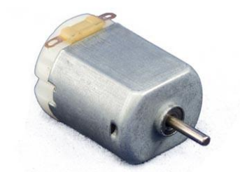

Figure 3: DC motor

A DC motor is any of a class of rotary electrical machines that converts direct current electrical energy into mechanical energy. The most common types rely on the forces produced by magnetic fields [3]. Two DC motor used for this project. One DC motor is used to move the robotic arm upward and downward meanwhile the other one DC motor is used to grip and release an object.

1. ATmega328P microcontroller

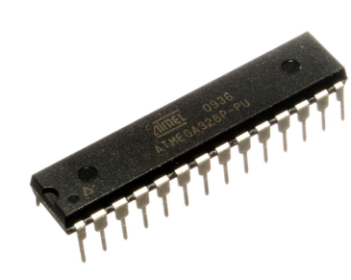

Figure 4: ATmega328P microcontroller

This ATmega328P chip is supported with a full suite of program and system development tools including C compiler, macro assemblers, program simulator and evaluation kits. In this project, it is use to receive input data from accelerometer sensor. Then it will send the output data to the RF transmitter.

**4.2 CIRCUIT DESIGN**

There are two part happened in this project regarding of the circuit design. The figure below shows the circuit of first part of this project. The first part is about using Arduino ATmega328P microcontroller to receive input data from accelerometer sensor and send the output to the RF module. The second part is about the 8051 microcontroller receive data from RF module and transfer the output to the DC motors and LCD. The figure below shows the design circuit used in this project.

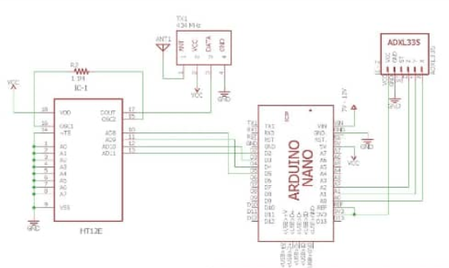

Figure 5: Design circuit

**5.0 SOFTWARE DESIGN**

**5.1 System Flowchart**

LCD display “grip object”

Transmitter

RF as output

LEFT

DOWN

LCD display “move downward”

LCD display “move upward”

LCD display “release object”

Accelerometer as input sensor

RIGHT

UP

Hand movement

1

1

Receiver

Robot hand move release

Robot hand move grip

Robot hand move downward

Robot hand move upward

Direction

UP

RIGHT

LEFT

DOWN

**5.2 ASSEMBLY LANGUAGE**

ORG 00H

DAT EQU P2

EN EQU P0.5

RW EQU P0.6

RS EQU P0.7

;-----START MAIN PROGRAM-------

;----------SWITCH------------

main: MOV P0, #00000000B;

MOV A,P3

MOV R4,A

MOV A, R4

ANL A, #00100000B ;SWITCH K3

JZ task1

AJMP jmp1

task1: ljmp sw1

AJMP jmp1

jmp1: MOV A, R4

ANL A, #00010000B ;SWITCH K4

JZ task2

AJMP jmp2

task2: ljmp sw2

AJMP jmp2

jmp2: MOV A, R4

ANL A, #00001000B ;SWITCH K5

JZ task3

AJMP jmp3

task3: ljmp sw3

AJMP jmp3

jmp3: MOV A, R4

ANL A, #00000100B ;SWITCH K6

JZ task4

AJMP main

task4: ljmp sw4

AJMP main

;------MOTOR MOVE CLOCK WISE----

motor1: MOV P0, #00000100B ;MOVE MOTOR 1 CLOCKWISE

ACALL DELAY

RET

motor2: MOV P0, #00001000B ;MOVE MOTOR 1 ANTICLOCKWISE

ACALL DELAY

RET

motor3: MOV P0, #00010000B ;MOVE MOTOR 2 CLOCKWISE

ACALL DELAY

RET

motor4: MOV P0, #00100000B ;MOVE MOTOR 2 ANTICLOCKWISE

ACALL DELAY

RET

;------DISPLAY LCD-------------

;-----LEFT----------

SW1: MOV A,#38H

ACALL CMND

MOV A,#0CH

ACALL CMND

MOV A,#01H

ACALL CMND

MOV A,#80H

ACALL CMND

MOV A,#3CH

ACALL CMND

MOV A,#'R'

ACALL DISP

MOV A,#'E'

ACALL DISP

MOV A,#'L'

ACALL DISP

MOV A,#'E'

ACALL DISP

MOV A,#'A'

ACALL DISP

MOV A,#'S'

ACALL DISP

MOV A,#'E'

ACALL DISP

MOV A,#0C4H

ACALL CMND

MOV A,#'O'

ACALL DISP

MOV A,#'B'

ACALL DISP

MOV A,#'J'

ACALL DISP

MOV A,#'E'

ACALL DISP

MOV A,#'C'

ACALL DISP

MOV A,#'T'

ACALL DISP

ljmp motor1

;-----RIGHT-------

SW2: MOV A,#38H

ACALL CMND

MOV A,#0CH

ACALL CMND

MOV A,#01H

ACALL CMND

MOV A,#80H

ACALL CMND

MOV A,#3CH

ACALL CMND

MOV A,#'G'

ACALL DISP

MOV A,#'R'

ACALL DISP

MOV A,#'I'

ACALL DISP

MOV A,#'P'

ACALL DISP

MOV A,#0C4H

ACALL CMND

MOV A,#'O'

ACALL DISP

MOV A,#'B'

ACALL DISP

MOV A,#'J'

ACALL DISP

MOV A,#'E'

ACALL DISP

MOV A,#'C'

ACALL DISP

MOV A,#'T'

ACALL DISP

ljmp motor2

;-----UP-------

SW3: MOV A,#38H

ACALL CMND

MOV A,#0CH

ACALL CMND

MOV A,#01H

ACALL CMND

MOV A,#80H

ACALL CMND

MOV A,#3CH

ACALL CMND

MOV A,#'M'

ACALL DISP

MOV A,#'0'

ACALL DISP

MOV A,#'V'

ACALL DISP

MOV A,#'E'

ACALL DISP

MOV A,#0C4H

ACALL CMND

MOV A,#'U'

ACALL DISP

MOV A,#'P'

ACALL DISP

MOV A,#'W'

ACALL DISP

MOV A,#'A'

ACALL DISP

MOV A,#'R'

ACALL DISP

MOV A,#'D'

ACALL DISP

ljmp motor3

;-----RIGHT-------

SW4: MOV A,#38H

ACALL CMND

MOV A,#0CH

ACALL CMND

MOV A,#01H

ACALL CMND

MOV A,#80H

ACALL CMND

MOV A,#3CH

ACALL CMND

MOV A,#'M'

ACALL DISP

MOV A,#'0'

ACALL DISP

MOV A,#'V'

ACALL DISP

MOV A,#'E'

ACALL DISP

MOV A,#0C4H

ACALL CMND

MOV A,#'B'

ACALL DISP

MOV A,#'A'

ACALL DISP

MOV A,#'C'

ACALL DISP

MOV A,#'K'

ACALL DISP

MOV A,#'W'

ACALL DISP

MOV A,#'A'

ACALL DISP

MOV A,#'R'

ACALL DISP

MOV A,#'D'

ACALL DISP

ljmp motor4

;--------LOOP FOREVER-----

HERE: SJMP HERE

;----------------------SUBROUTINE TO SEND COMMAND VALUE---------

CMND: MOV DAT,A

CLR RS

CLR RW

SETB EN

CLR EN

ACALL DELY

RET

;------------------------SUBROUTINE TO SEND VALUE DATA---------------

DISP: MOV DAT,A

SETB RS

CLR RW

SETB EN

CLR EN

ACALL DELY

RET

;-------------SUBROUTINE TO CHECK BUSY FLAG STATUS------

DELY: CLR EN

CLR RS

SETB RW

MOV DAT,#0FFH

SETB EN

MOV A,DAT

JB ACC.7,DELY

CLR EN

CLR RW

RET

;----------SUBROUTINE DELAY-------

DELAY: MOV R2,#1

LOOP2: MOV R1,#255

LOOP1: MOV R0,#255

LOOP0: DJNZ R0, LOOP0

DJNZ R1, LOOP1

DJNZ R2, LOOP2

RET

END

**6.0 TESTING AND DEBUGGING**

There are many errors occurred when conducting the project such as software error and hardware error. On the software part, the program for the accelerometer is really complicated and difficult to find the reference about the 8051 assembly language for the components in the Internet. The program for the receiver and the accelerometer is easier with Arduino rather than 8051 microcontrollers, as we also lack of microcontroller because every team are using 8051 microcontrollers on the hardware part. So, by using the Arduino microcontroller, the project will have two circuit that perform different process. One of the process is for receiving signal from accelerometer sensor through Arduino microcontroller for RF transmitter transmitting data. The other one process is the 8051 microcontroller receiving the RF signal and transfer the output to the motors and LCD. Other than that, the prototype that we receiver has many defectives such as the screw is loose and the size of the hole for the motor is small for the DC motor to fit in. Because of that, we use hot glue gun and cable tie to attach the motor on the prototype.

**6.1 Hardware Testing**

Many hardware components are used in this project. Firstly, we use the L293D chip to control the motor. But it will require more wiring to connect the motor and the chip. We swap the chip over L298N motor driver that have many advantages over the chip such as less wiring and easier to control 2 DC motors. The motor drive also is neat because it is already soldered on a board. Other than that, the accelerometer also we use the digital (ADXL345) rather than analog (ADXL335) which is better because of it has inbuilt function such as free fall detection activity and the range of ‘G” in ADXL345 can be selected while the other one is fixed. It also is more accurate, have inbuilt sleep modes and consumes less power.

**6.2 Debugging Project**

The error in the Arduino’s program and the 8051 microcontroller’s assembly language has been troubleshooting to find the ‘sweet spot’ or the suitable for the DC motor and the radio transmitter and receiver. The project also need to be used the converter for the C++ language to assembly language as we use 2 different boards. The sensitivity of the accelerometer also has been calibrated to find the best possible gesture for the process.

**7.0 RESULTS**

**7.1 Early state Product**

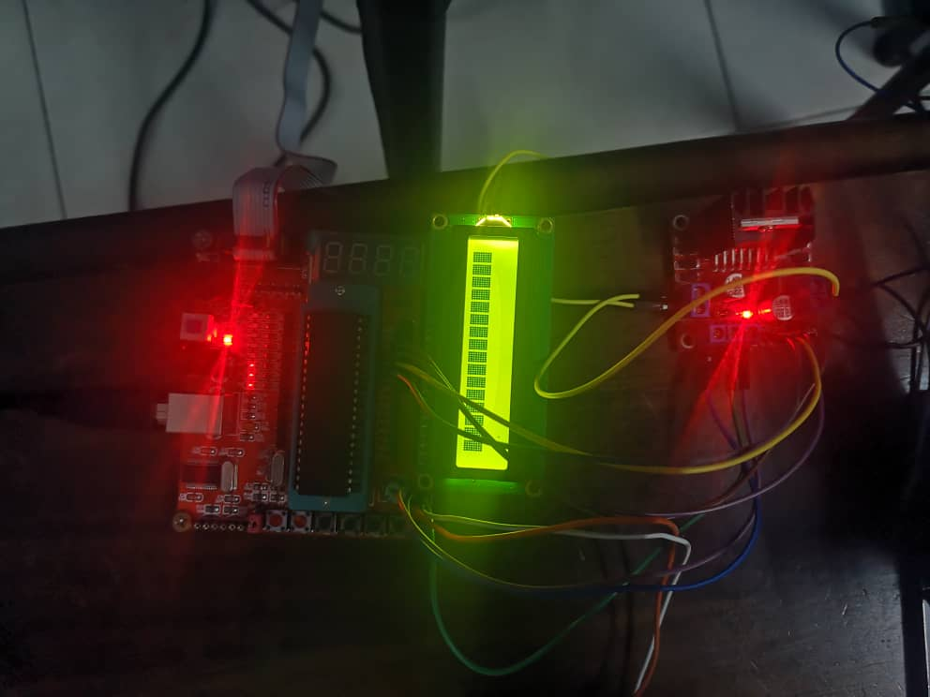

Figure 7.1: 8051 Microcontroller with LCD and motor driver

**7.2 Final Product (Prototype)**

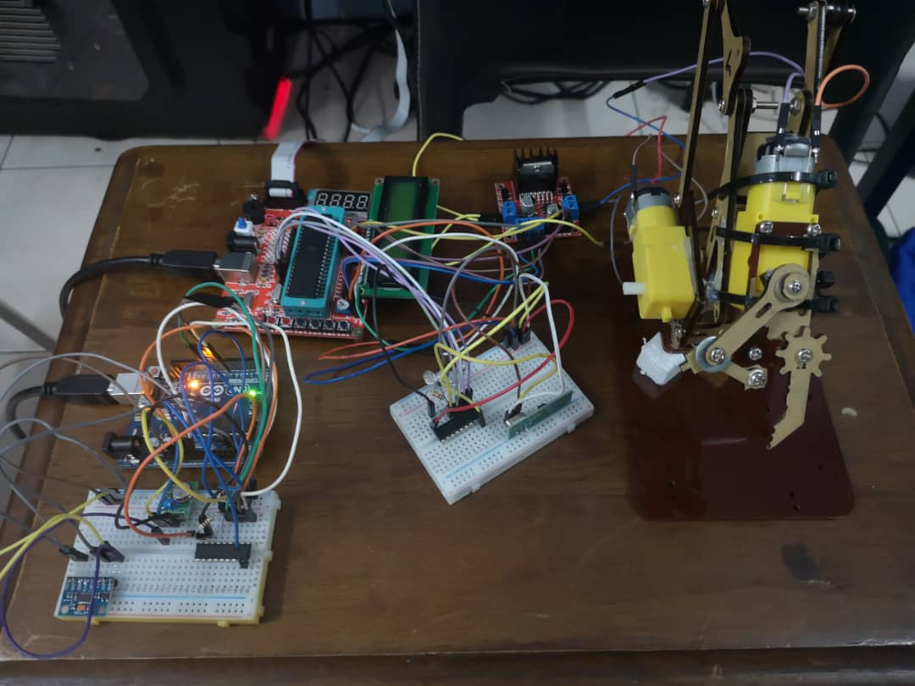

Figure 7.2: Finished prototype of the robotic arm

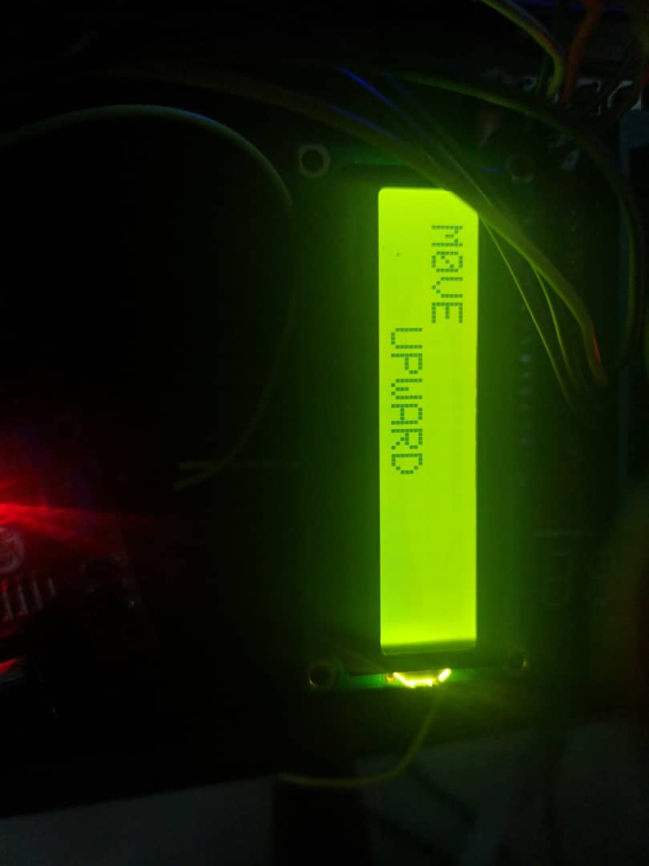

Figure 7.3: The LCD display the action of the robotic arm “move upward”

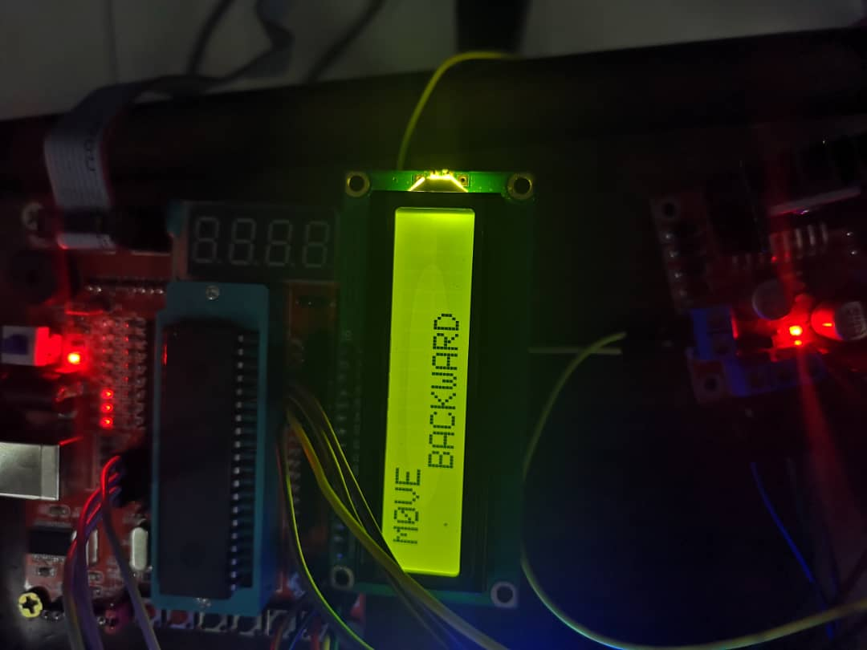

Figure 7.4: The LCD display the “move backward” action

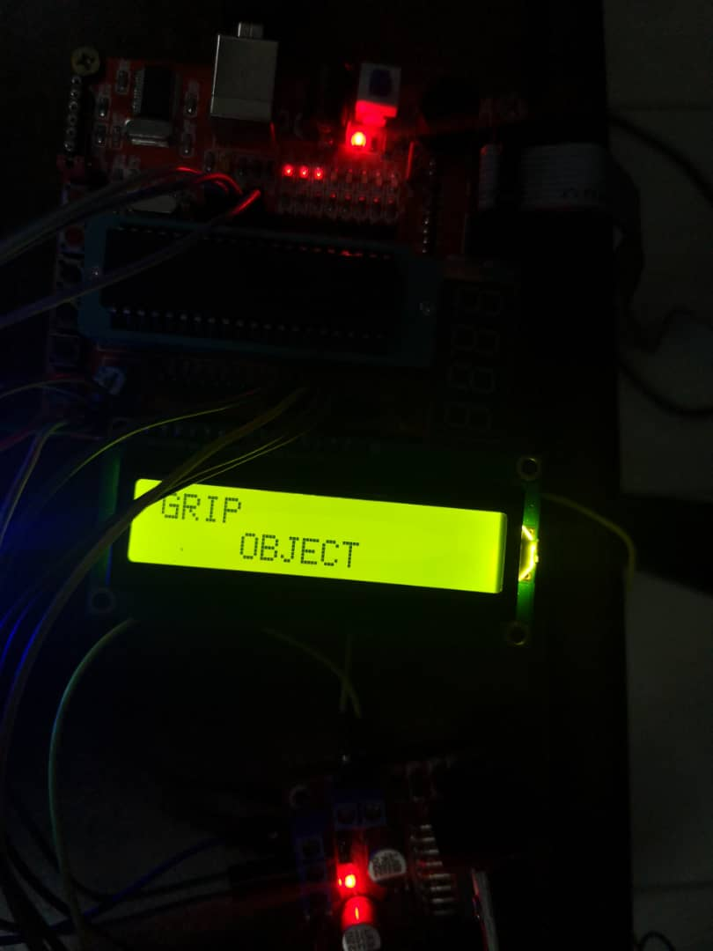

Figure 7.5: The LCD display the “grip object” task

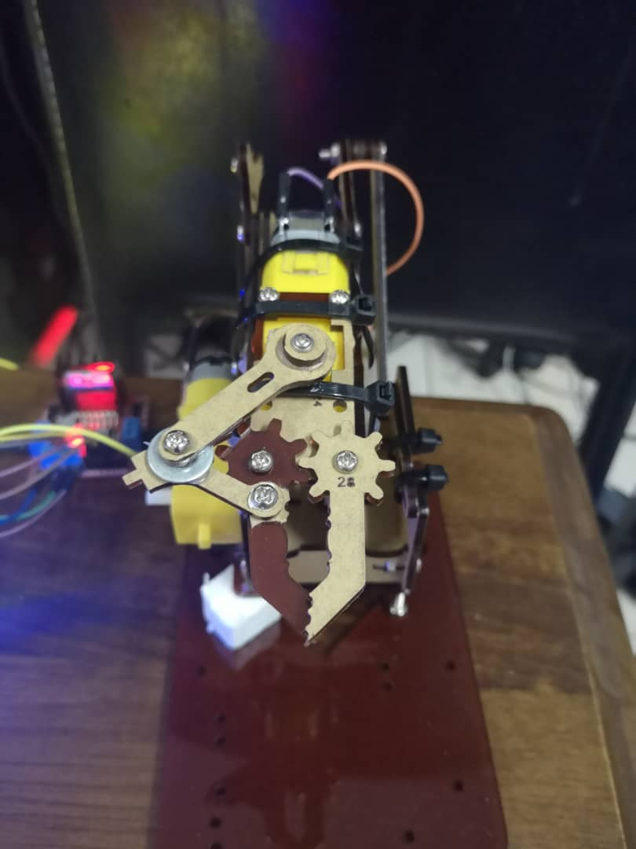

Figure 7.6: The ‘hand’ or clipper of the robotic arm in “grip object” state

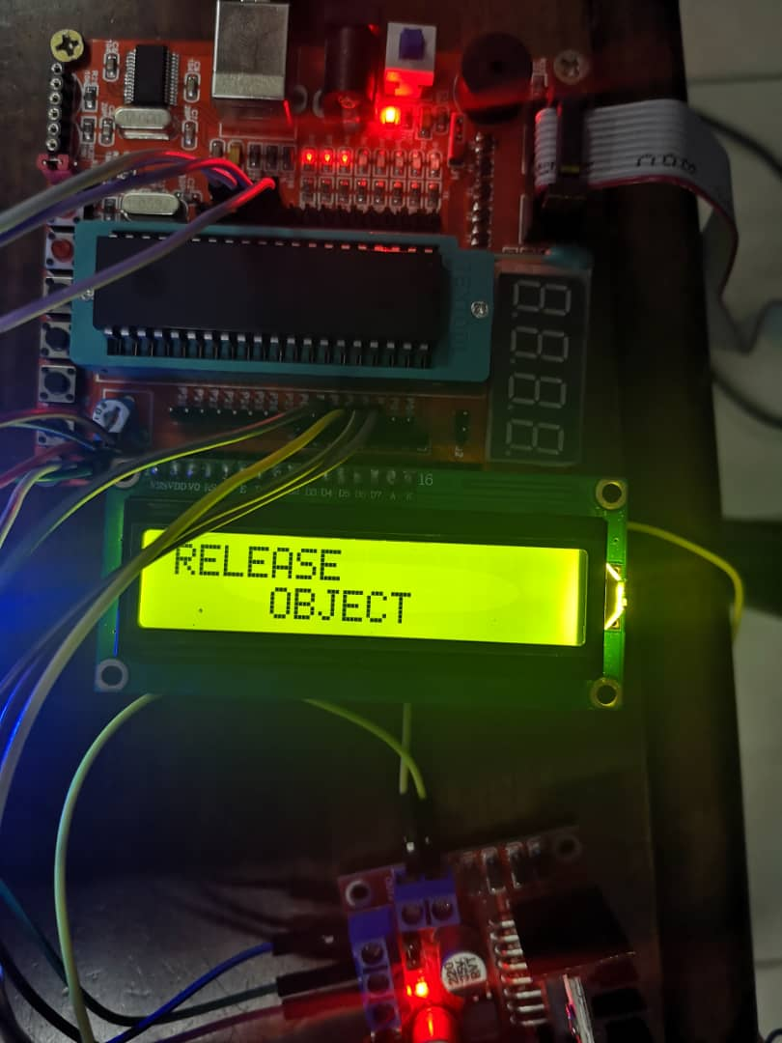

Figure 7.7: The LCD shows the task of the robotic arm in “release object”

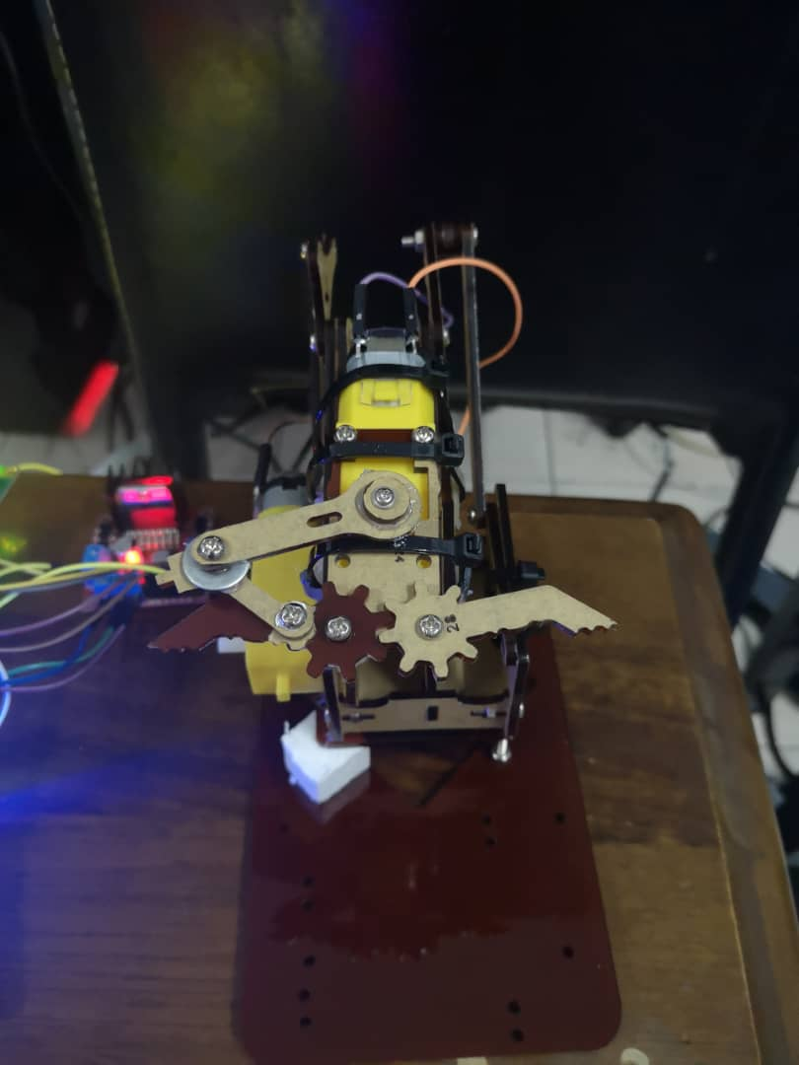

Figure 7.8: The “release object” state of the robotic arm

**8.0 ENTREPRENEURIAL OPPORTUNITY**

When the world is now growing towards futuristic method to solve any problems in any problem, there are many things involving the mechanical and electrical are upgrading towards the goal of the future world. With the rapid development of artificial intelligence (A.I) and robots, this project is very suitable for the goal as it achieves the used of robots in industrial part replacing the human power to do the heavy works.

This project, named as Hand Controlled Robotic Arm will be the operator that will do the lifting for the heavy object with the bigger model. This project also is an upgrade from the already-in-use robotic arm that need to be control using a controller. With the uses of the wireless control, that is controlled by the gesture of the hand will make it easier and smoother movement same as human arm. This project with the small model can be used in laboratory that handle many dangerous substances that can harm human life.

So, with this machine, the research can be done without harming the scientist’s life. This also can be applied to the astronaut that doing the research in outer space. Robots and space technologies is very common nowadays as robot didn’t have to do human basic needs. They also can carry many things that maybe is harmful to human. With the implementation of the project, the production of the industrial place will be enhanced because the robot can work all day long.

Other than that, this project also can be upgraded with the use of the radio frequency transmitter and receiver (RF) as it can be controlled from far away thus making it is safe for the user to handle it far from the danger zone. It also can be installed with Bluetooth, infrared or Wi-Fi module to transmit the data user to machine. Lastly, this project can be implemented on bigger or smaller size according to the workload or type of work that it is need to do. Hence, it is suitable for all the type of working environment in the world.

**9.0 FINANCIAL MANAGEMENT**

The table below show the expenditure that been used to make this project from basic to finished prototype: -

|  |  |  |  |  |
| --- | --- | --- | --- | --- |
| NO. | ITEM | QUANTITY | PRICE (RM) | TOTAL (RM) |
| 1 | 8051 microcontroller | 1 | 65.00 | 65.00 |
| 2 | LCD | 1 | 10.00 | 10.00 |
| 3 | DC motor | 2 | 7.00 | 14.00 |
| 4 | ATmega328P microcontroller | 1 | 100.00 | 100.00 |
| 5 | RF module | 1 | 25.50 | 25.50 |
| 6 | Accelerometer sensor | 1 | 17.00 | 17.00 |
| 7 | Robotic arm chassis | 1 | 57.00 | 57.00 |
| 8 | Encoder (HT12D) | 1 | 5.50 | 5.50 |
| 9 | Decoder (HT12E) | 1 | 5.50 | 5.50 |
| 10 | Breadboard | 2 | 8.50 | 17.00 |
| 11 | Resistor 51kΩ & 1MΩ | 2 | 0.20 | 0.40 |
| 12 | IC Socket 16P | 1 | 1.30 | 1.30 |
| 13 | Wires | 200 | 20.00 | 20.00 |
|  |  |  |  | 338.20 |

**10.0 CONCLUSION AND RECOMMENDATION**

**10.1 Conclusion**

In conclusion, all the objectives of this Hand Motion Controlled Robotic Arm project has been done and accomplished. This project also is successful as it has fulfilled the job to move upward, move downward, grip and release the object. We also have used the combination of 8051 microcontroller’s assembly language and Arduino’s C++ language to make this project perfect. Many method and troubleshooting has been done just to make this project work as it should be. Other than that, making a robot arm that will be control by the gesture of human’s hand is very complicated, because it requires a lot of program to improve the sensitivity of the program to react based on the hand gesture of the user. Lastly, we can improve the industrial and other sector that requires the machine as we can decrease the needs of human power to make heavy works.

**10.2 Recommendation**

For this project, there are many improvements that can be added to upgrade the system. Firstly, the project can be improved by implementing artificial intelligence (A.I) to control the robotic arm without a need for human to control it. The use of A.I in this project can improve the efficiency of the project as it will keep learning of itself to do the work that has been given. With this also, we can prevent from human error that might making the system damaged. Next, we also can improve the way of the data to be transmitted to make it easier to be controlled far from the system. This improvement can make the work of the astronaut easier as they can control the robot arm without a need to get out from the spaceship. They also can be controlled by the ground station as if the data is higher and can be transmitted through the satellite. Lastly, we hope that this project can make a contribution to human life and for the future world of civilization.

REFERENCES

1. Brian Barkly Graham. [2000]. Using an Accelerometer Sensor to Measure Human Hand Motion. Massachusetts Institute of Technology.

[2] [https://howtomechatronics.com/tutorials/arduino/arduino-dc-motor-control-tutorial-l298n-pwm-h-bridge/#](https://howtomechatronics.com/tutorials/arduino/arduino-dc-motor-control-tutorial-l298n-pwm-h-bridge/)

[3] <https://en.wikipedia.org/wiki/DC_motor>

[4] <https://maker.pro/arduino/projects/hand-gesture-controlled-robotic-arm-arduino>

[5] <http://nevonprojects.com/hand-motion-controlled-robotic-arm/>

[6] <https://www.instructables.com/id/Handgesture-controlled-robot-with-robotic-arm/>